**Hive - Task 1**

**Hive:**

Hive gives a SQL-like interface to manage data. It is used in Amazon H3 file system. It also support HiveQL. Hive implicitly codeword hiveQL statement into Adirected acyclic graph of mapreduce those the spark jobs.

It support Advance features such as indices, partition, buckets, asummetric transactions, custom user defined functions, joins, sampling & many others. Lots of them take a considerable amount of time if implemented manually.

**Create directory in Hadoop:**

hdfs dfs –mkdir /expedia

The above query will create directory with name expedia in hdfss.

**Copy file to Hadoop File System:**

hdfs dfs –put train.csv /expedia/

This query will print train.csv in expedia directory in hdfs.

**Create Database in hive:**

CREATE DATABASE IF NOT EXISTS expedia;

This query will create database with expedia. If database is already exists than this query will not do any change.

**Create table in hive:**

CREATE TABLE IF NOT EXIST train (date_time string, site_name int, posa_continent int, user_location_country int, user_location_region int, user_location_city int, orig_destination_distance double, user_id int, is_mobile tinyint, is_package int, channel int, srch_ci string, srch_co string, srch_adults_cnt int, srch_children_cnt int, srch_rm_cnt int, srch_destination_id int, srch_destination_type_id int, is_booking tinyint, cnt bigint, hotel_continent int, hotel_country int, hotel_market int, hotel_cluster int) ROW FORMATE DELIMITED FIELDS TERMINATED BY "," STORED AS TEXTFILE LOCATION "/expedia/"

In above query, I have given the hdfs location of train.csv which is “/expedia/”. So, this table is form over it.

**Displaying first 100 rows**

You can see here first 100 rows which are same as actual train.csv file.

SELECT * from train LIMIT 100;

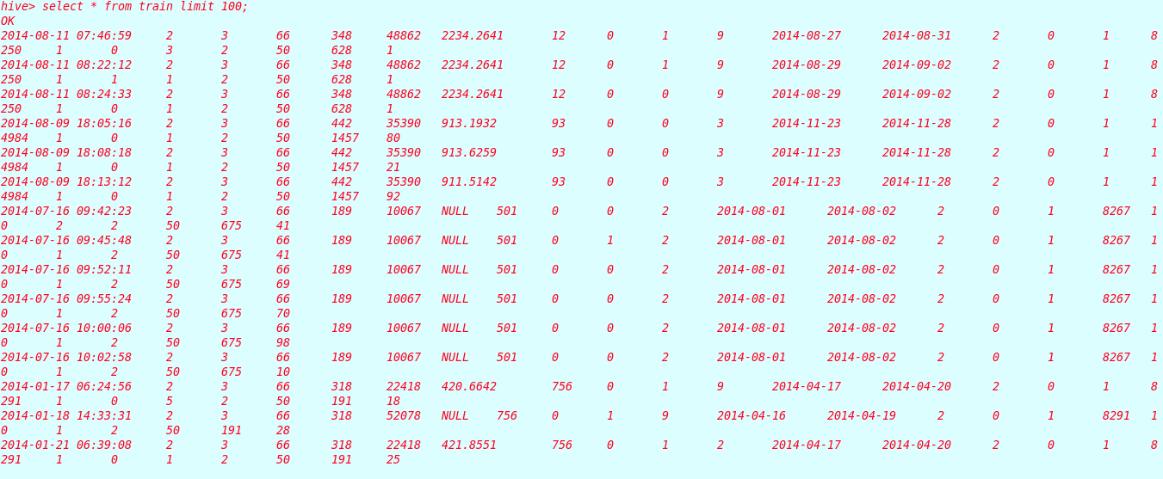

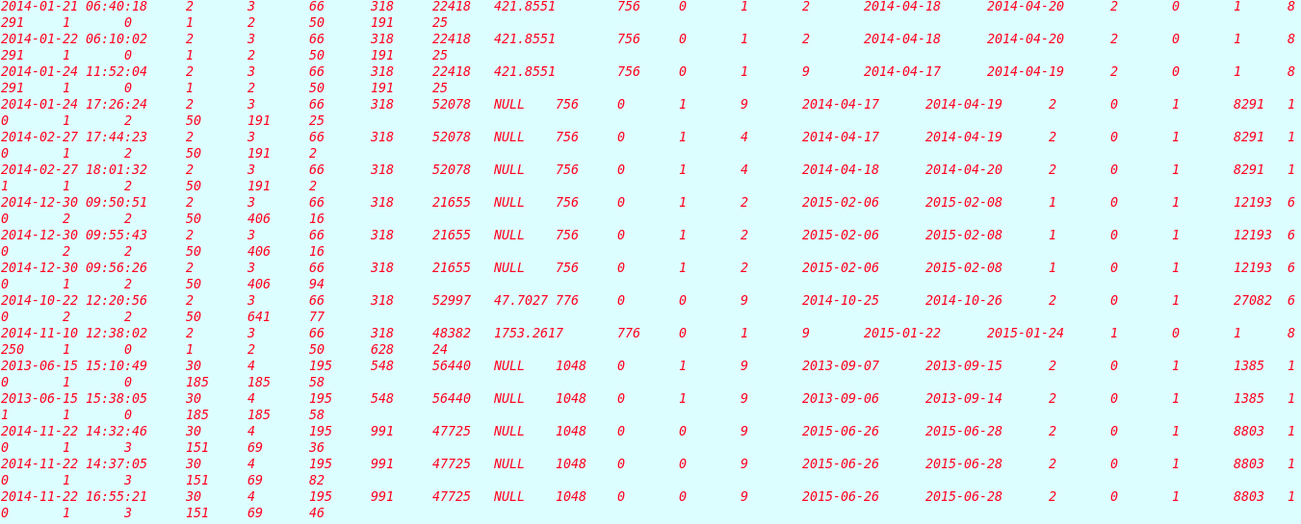

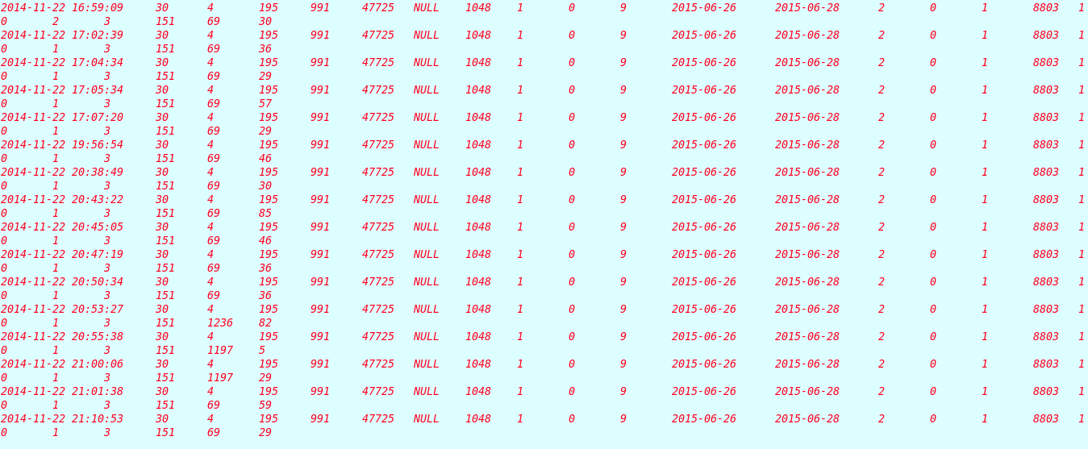

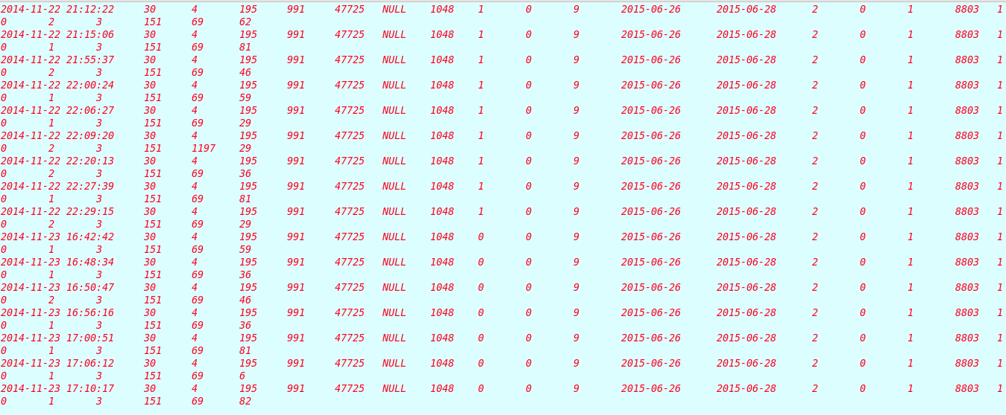

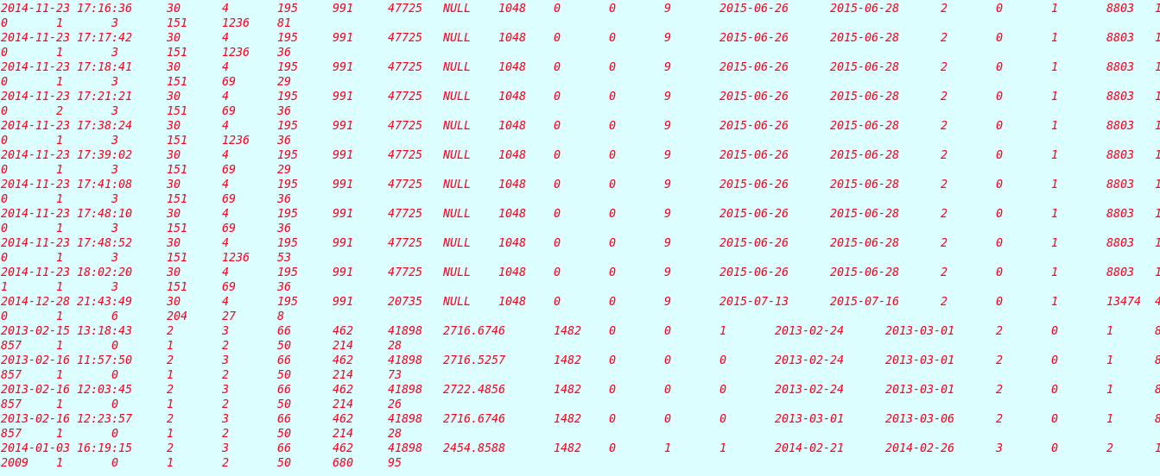

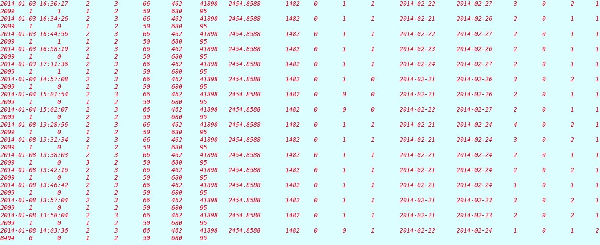

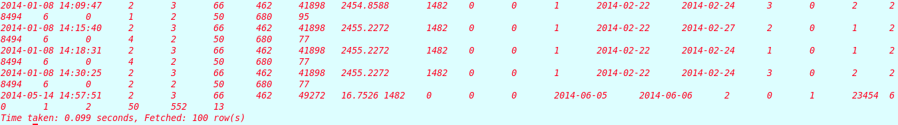

**Task 1:**

**Write hive script to calculate Top 3 most popular countries where booking is successful (booking = 1), make screenshots before and after script execution, copy hive script to archive.**

SELECT bookingonerows.hotel_country, COUNT(*) AS cnt FROM (SELECT * FROM train WHERE is_booking = 1) AS bookingonerows GROUP BY bookingonerows.hotel_country ORDER BY cnt DESC LIMIT 3;

First, This query filter all those rows whose booking status is equals to 1. Then I use group by command to create group of countries. Then use ORDER BY & LIMIT command to show Top 3 values.

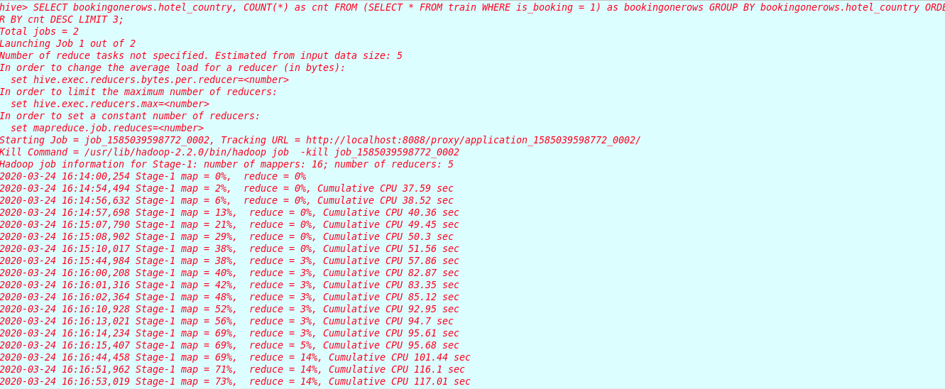

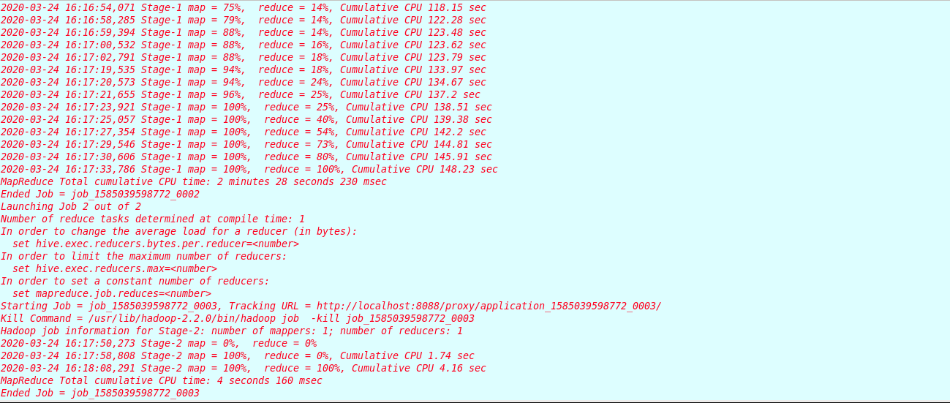

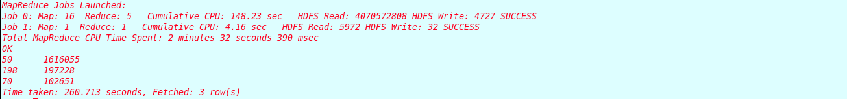

**Query Result:**

|  |  |
| --- | --- |
| Hotel Country | Count |
| 50 | 1616055 |
| 198 | 197228 |
| 70 | 102651 |